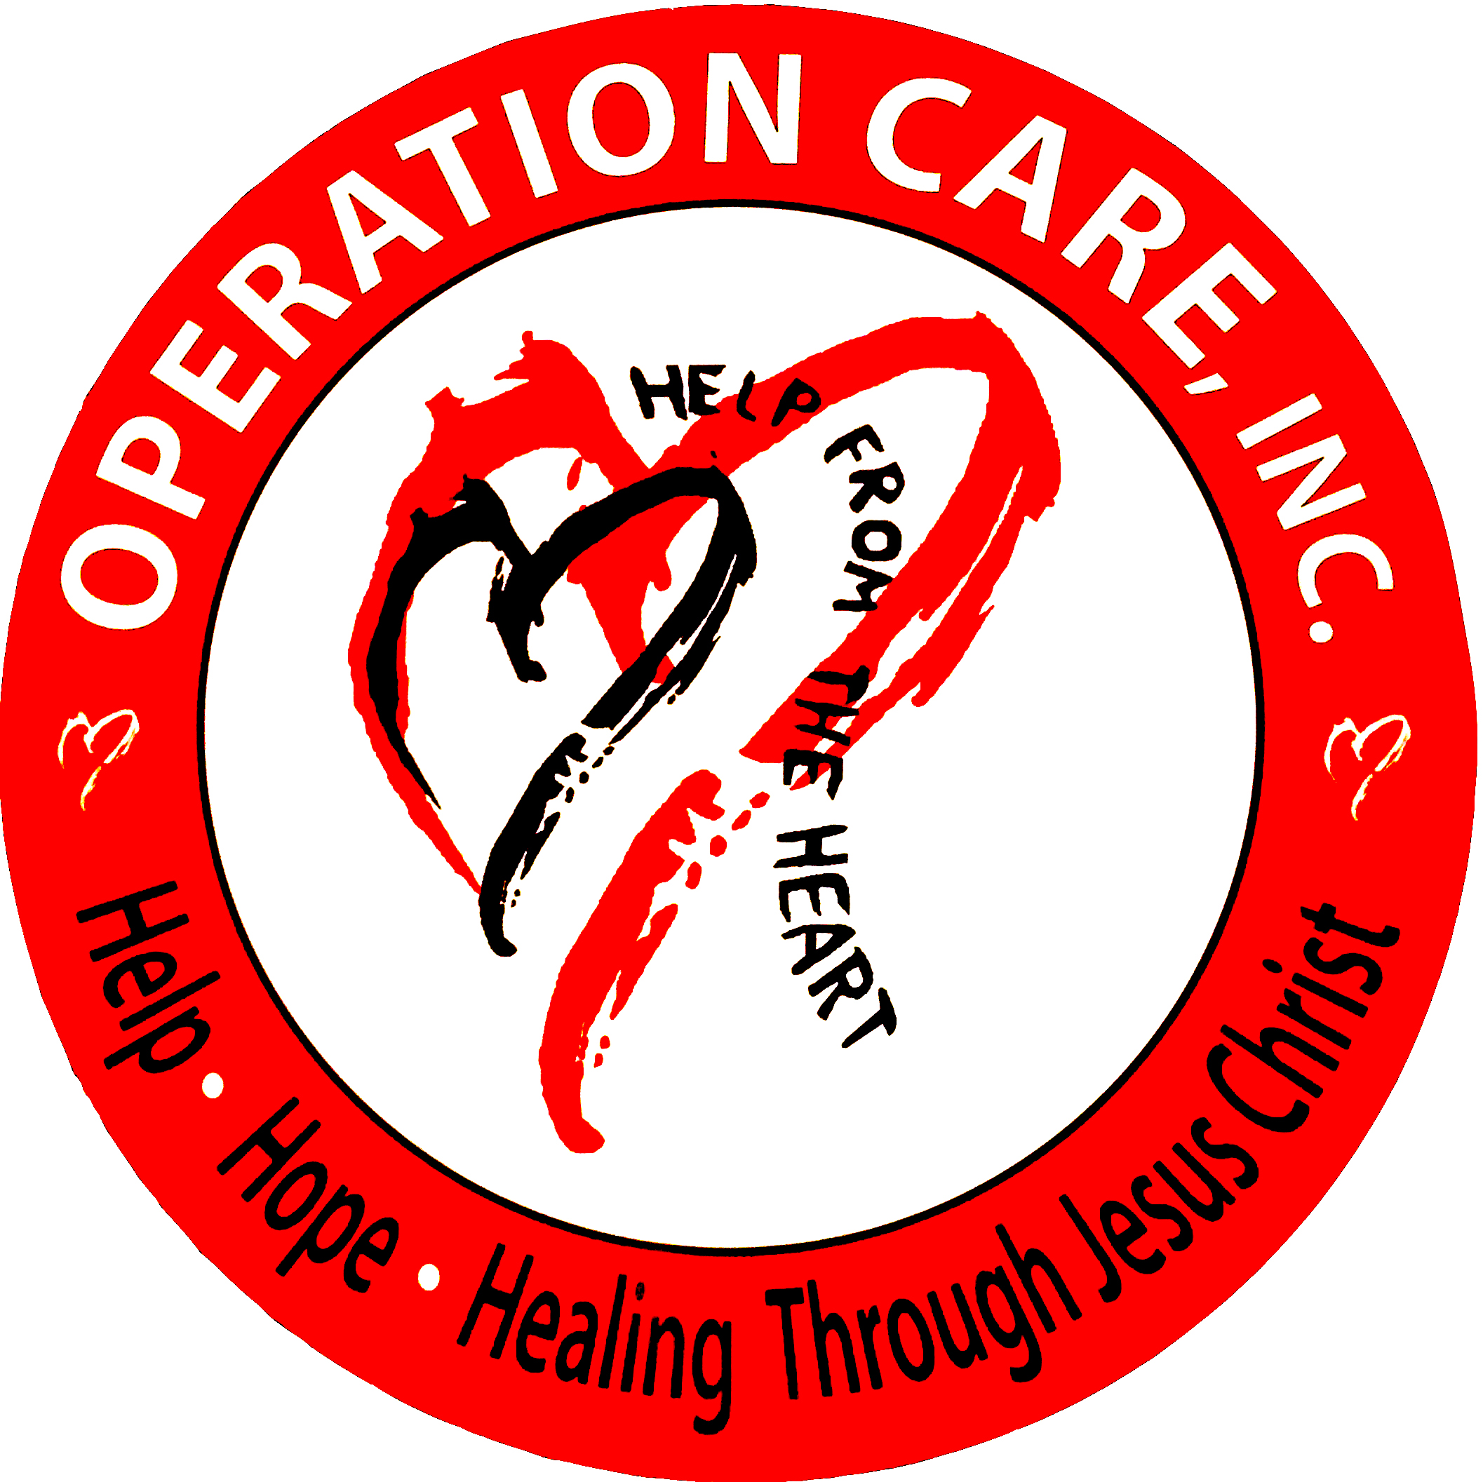

Operation Care, Inc. Fiscal Year Ended 6/30/2025 Annual Performance Report

Mission Statement
Operation Care is a Christian ministry that seeks to provide for the physical, spiritual, emotional, and social well-being of people in need in a loving, compassionate environment in the name of Jesus Christ.
Operation Care Privacy Policy
Your privacy is important to us. To better protect your privacy, we provide this notice explaining our online information practices. Our privacy policy is simple: we collect no information about you unless you choose to provide that information to us. In addition, we do not give, share, sell, or transfer any personal information about you to any third parties.

To prevent unauthorized access, maintain accuracy, and ensure the correct use of information, we have put in place appropriate physical, electronic, and managerial procedures to safeguard and secure any information that we collect. If you have questions about our privacy practices, you can contact us at the postal or email address posted on this website.

FYE June 30, 2025 Financial Report

Total Revenue | $ 2,576,941
Program Service Expense | $ 2,338,414
Administrative Expenses | $ 97,329
Fund Raising Expense | $ 25,739
Net Assets | $ 1,404,444

FYE June 30, 2025 Individual Services Administered

Shelter & Housing Program | 54
Medical/Dental Care Program | 9,505
Emergency Assistance Program | 3,471
Community Christmas for Children | 500
Total Persons Served in FYE 6/30/2024 | 13,530
Board of Directors (*voting member)
Name | Title | Company
Steve Hornback | *Chairman and Treasurer | Citizens Union Bank
Teresa Barnes | *Vice Chair | Get Fit by Teresa and Re/Max Realty
Susan Nally | * Secretary | Roll Forming Corp.
Diane Collins | *Director | Retired Pre-School Teacher
Mindi McGinnis | *Director | Substitute Teacher - SCPS
Louise McLaughlin | *Director | Retired School Teacher
Laura Moorman | *Director | Retired School Teacher
Marc Webb | *Director | Victory Baptist Church

